ISLAMIC UNIVERSITY OF TECHNOLOGY

Organization of Islamic Cooperation

Board Bazar, Gazipur

Lab 05

EEE 4484

Safayat Bin Hakim

Full-Adder Circuit
Source Code:

LIBRARY ieee;
USE ieee.std_logic_1164.ALL;
ENTITY full_adder IS
PORT (
Num1, Num2, CarryIn : IN std_logic;
Sum, CarryOut : OUT std_logic
);
END full_adder;
ARCHITECTURE behavorial OF full_adder IS
BEGIN
Sum <= Num1 XOR Num2 XOR CarryIn;
CarryOut <= (Num1 AND Num2) OR (CarryIn AND Num1) OR (CarryIn AND Num2);
END behavorial;
VHDL

Testbench Code:

LIBRARY ieee;
USE ieee.std_logic_1164.ALL;
ENTITY tb_full_adder IS
END tb_full_adder;
ARCHITECTURE behavior OF tb_full_adder IS
COMPONENT full_adder
PORT (
Num1, Num2, CarryIn : IN std_logic;
Sum, CarryOut : OUT std_logic
);
END COMPONENT;
SIGNAL tb_Num1, tb_Num2, tb_CarryIn : std_logic := '0';
SIGNAL tb_Sum, tb_CarryOut : std_logic;
BEGIN
uut : full_adder
PORT MAP(
Num1 => tb_Num1,
Num2 => tb_Num2,
CarryIn => tb_CarryIn,
Sum => tb_Sum,
CarryOut => tb_CarryOut
);
stim_proc : PROCESS
BEGIN
WAIT FOR 100 ns;
tb_Num1 <= '1';
tb_Num2 <= '0';
tb_CarryIn <= '0';
WAIT FOR 50 ns;
tb_Num1 <= '0';
tb_Num2 <= '1';
tb_CarryIn <= '0';
WAIT FOR 50 ns;
tb_Num1 <= '1';
tb_Num2 <= '1';
tb_CarryIn <= '0';
WAIT FOR 50 ns;
tb_Num1 <= '0';
tb_Num2 <= '0';
tb_CarryIn <= '1';
WAIT FOR 50 ns;
tb_Num1 <= '1';
tb_Num2 <= '0';
tb_CarryIn <= '1';
WAIT FOR 50 ns;
tb_Num1 <= '0';
tb_Num2 <= '1';
tb_CarryIn <= '1';
WAIT FOR 50 ns;

tb_Num1 <= '1';
tb_Num2 <= '1';
tb_CarryIn <= '1';
WAIT FOR 50 ns;
END PROCESS;
END;
VHDL

Waveshape:
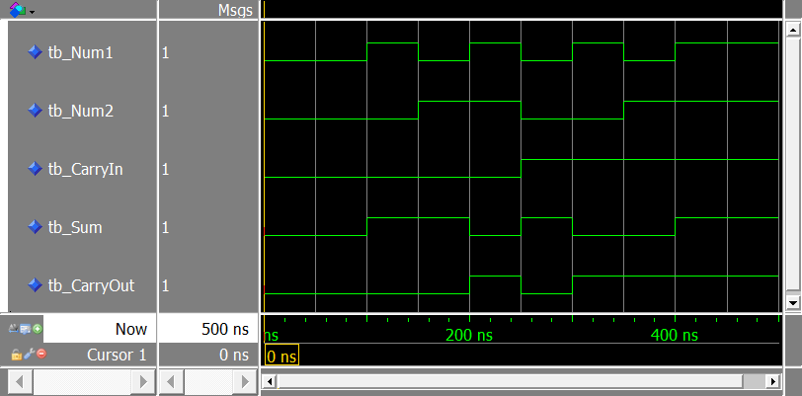

1-to-8 Demultiplexer
Source Code:

LIBRARY ieee;
USE ieee.std_logic_1164.ALL;
ENTITY demux_1_8 IS
PORT (
input : IN std_logic;
sel : IN std_logic_vector(2 DOWNTO 0);
output : OUT std_logic_vector(7 DOWNTO 0)
);
END ENTITY;
ARCHITECTURE behavioral OF demux_1_8 IS
BEGIN
PROCESS (input, sel)
BEGIN
output <= "00000000";
CASE sel IS
WHEN "000" => output(0) <= input;
WHEN "001" => output(1) <= input;
WHEN "010" => output(2) <= input;
WHEN "011" => output(3) <= input;
WHEN "100" => output(4) <= input;
WHEN "101" => output(5) <= input;
WHEN "110" => output(6) <= input;
WHEN "111" => output(7) <= input;
WHEN OTHERS => output <= "00000000";
END CASE;
END PROCESS;
END ARCHITECTURE behavioral;
VHDL

Testbench Code:
LIBRARY ieee;
USE ieee.std_logic_1164.ALL;
ENTITY tb_demux_1_8 IS
END tb_demux_1_8;
ARCHITECTURE behavior OF tb_demux_1_8 IS
COMPONENT demux_1_8
PORT (
input : IN std_logic;
sel : IN std_logic_vector(2 DOWNTO 0);
output : OUT std_logic_vector(7 DOWNTO 0)
);
END COMPONENT;
SIGNAL tb_input : std_logic := '0';
SIGNAL tb_sel : std_logic_vector (2 DOWNTO 0) := (OTHERS => '0');
SIGNAL tb_output : std_logic_vector (7 DOWNTO 0);
BEGIN
uut : demux_1_8
PORT MAP(
input => tb_input,
sel => tb_sel,
output => tb_output
);
stim_proc : PROCESS
BEGIN
WAIT FOR 100 ns;
tb_input <= '1';
tb_sel <= "000";
WAIT FOR 50 ns;
tb_sel <= "001";
WAIT FOR 50 ns;
tb_sel <= "010";
WAIT FOR 50 ns;

tb_sel <= "011";
WAIT FOR 50 ns;
tb_sel <= "100";
WAIT FOR 50 ns;
tb_sel <= "101";
WAIT FOR 50 ns;
tb_sel <= "110";
WAIT FOR 50 ns;
tb_sel <= "111";
WAIT FOR 50 ns;
WAIT;
END PROCESS;
END;
VHDL

Waveshape:
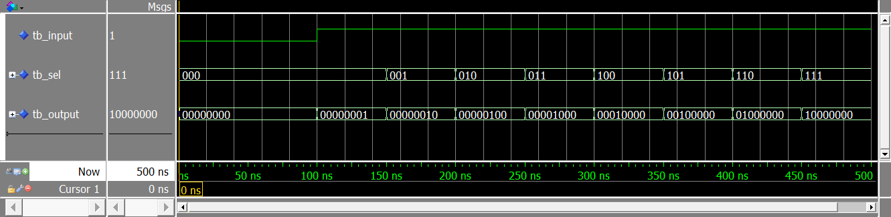

4-Bit ALU
Source Code:
LIBRARY ieee;
USE ieee.std_logic_1164.ALL;
USE ieee.numeric_std.ALL;
ENTITY alu_4_bit IS
PORT (
num1, num2 : IN signed(3 DOWNTO 0);
sel : IN std_logic_vector (1 DOWNTO 0);
result : OUT signed(3 DOWNTO 0)
);
END alu_4_bit;
ARCHITECTURE behavioral OF alu_4_bit IS
BEGIN
PROCESS (num1, num2, sel)
BEGIN
CASE sel IS
WHEN "00" => result <= num1 + num2;
WHEN "01" => result <= num1 - num2;
WHEN "10" => result <= num1 AND num2;
WHEN "11" => result <= num1 OR num2;
WHEN OTHERS => NULL;
END CASE;
END PROCESS;
END behavioral;
VHDL

Testbench Code:
LIBRARY ieee;
USE ieee.std_logic_1164.ALL;
USE ieee.numeric_std.ALL;
ENTITY tb_alu_4_bit IS
END tb_alu_4_bit;
ARCHITECTURE behavioral OF tb_alu_4_bit IS
COMPONENT alu_4_bit
PORT (
num1, num2 : IN signed(3 DOWNTO 0);
sel : IN std_logic_vector(1 DOWNTO 0);
result: OUT signed(3 DOWNTO 0)
);
END COMPONENT;
SIGNAL tb_num1, tb_num2 : signed(3 DOWNTO 0) := (OTHERS => '0');
SIGNAL tb_sel : std_logic_vector(1 DOWNTO 0) := (OTHERS => '0');
SIGNAL tb_result : signed(3 DOWNTO 0);
BEGIN
uut : alu_4_bit
PORT MAP(
num1 => tb_num1,
num2 => tb_num2,
sel => tb_sel,
result => tb_result
);
stim_proc : PROCESS
BEGIN
WAIT FOR 100 ns;
tb_num1 <= "1001";
tb_num2 <= "1111";
tb_sel <= "00";
WAIT FOR 50 ns;
tb_sel <= "01";
WAIT FOR 50 ns;
tb_sel <= "10";
WAIT FOR 50 ns;
tb_sel <= "11";
END PROCESS;
END behavioral;
VHDL

Waveshape:

Synchronous 5-Bit Shift Register
Source Code:
LIBRARY ieee;
USE ieee.std_logic_1164.ALL;
ENTITY shift_reg_5_bit IS
PORT (
input : IN STD_LOGIC_VECTOR (4 DOWNTO 0);
clock : IN STD_LOGIC;
output : OUT STD_LOGIC_VECTOR (4 DOWNTO 0)
);
END ENTITY shift_reg_5_bit;
ARCHITECTURE behavioral OF shift_reg_5_bit IS
BEGIN
PROCESS (clock, input)
BEGIN
IF (clock'EVENT AND clock = '1') THEN
output <= input;
END IF;
END PROCESS;
END behavioral;
VHDL

Testbench Code:
LIBRARY ieee;
USE ieee.std_logic_1164.ALL;
USE ieee.numeric_std.ALL;
ENTITY tb_shift_reg_5_bit IS
END ENTITY tb_shift_reg_5_bit;

ARCHITECTURE behavioral OF tb_shift_reg_5_bit IS
COMPONENT shift_reg_5_bit
PORT (
input : IN STD_LOGIC_VECTOR (4 DOWNTO 0);
clock : IN STD_LOGIC;
output : OUT STD_LOGIC_VECTOR (4 DOWNTO 0)
);
END COMPONENT shift_reg_5_bit;
SIGNAL tb_input : STD_LOGIC_VECTOR (4 DOWNTO 0) := (OTHERS => '0');
SIGNAL tb_clock : STD_LOGIC := '0';
SIGNAL tb_output : STD_LOGIC_VECTOR (4 DOWNTO 0);
CONSTANT clock_period : TIME := 100 ns;
BEGIN
uut : shift_reg_5_bit
PORT MAP(
input => tb_input,
clock => tb_clock,
output => tb_output
);
clk_process : PROCESS
BEGIN
tb_clock <= '0';
WAIT FOR clock_period/2;
tb_clock <= '1';
WAIT FOR clock_period/2;
END PROCESS;
stim_process : PROCESS
BEGIN
WAIT FOR 100 ns;
tb_input <= "00001";
WAIT FOR 100 ns;
tb_input <= "00010";
WAIT FOR 100 ns;
tb_input <= "00100";
WAIT FOR 100 ns;
tb_input <= "01000";
WAIT FOR 100 ns;
tb_input <= "10000";
WAIT FOR 100 ns;
tb_input <= "10001";
WAIT FOR 100 ns;
tb_input <= "10010";
WAIT FOR 100 ns;
tb_input <= "10100";
WAIT FOR 100 ns;
tb_input <= "11000";
WAIT FOR 100 ns;
tb_input <= "11010";
WAIT FOR 100 ns;
tb_input <= "11110";
WAIT FOR 100 ns;
tb_input <= "11111";
END PROCESS;
END behavioral;
VHDL

Waveshape:

